test | intended | evidence | Changes
Test home link and pass checker link | Clicking on the link takes you to the intended page | 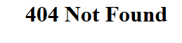  Password checker link didn’t work | The link did not have php on the end  changed to this:  now works
Test if ratings work correctly | It should output your score depending on how many requirements you met then give you advise based off what requirements you didn’t |   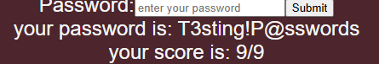 | This password meets all but one requirements and outputs the requirement it is missing  this password meets all requirements and represents as much

